Title: **OBSTETRIC AND NEONATAL OUTCOMES IN VACCINATED PREGNANT WOMEN WITH THE COVID-19 INFECTION: A PROSPECTIVE COHORT STUDY**

Author: **Chau Ngoc Minh1,2, Tran Ngoc Van Anh1, Dao Thi Hai Yen1, Nguyen Le Duy2, Vu Thi Lan Anh2, Vuong Thi Ngoc Lan2,3, Ho Manh Tuong1,2**

Affiliation

**Abstract**

**Aim**

To assess the impacts of Covid-19 infection on maternal and neonatal outcomes between pregnant women with and without Covid-19 infection.

**Methods**

This was a prospective cohort study conducted at My Duc Hospital from August 2021 to November 2021. Participants were followed from one week after vaccination to 28 days postpartum. Post-vaccination side-effects, obstetric and neonatal outcomes were compared between pregnant women with and without the Covid-19 infection.

**Results**

Between August 2021 and November 2021, there were 917 pregnant women vaccinated. Out of them, 954 (73 pregnant women with Covid-19 infection, 73 pregnant women without infection after matching based on the mother's age and the number of their previous pregnancies) had given birth. The pregnant women with Covid-19 infection had mean gestational age at birth was higher than the pregnant women without Covid-19 infection (38.7±1.2 vs 37.9±2.5, p=0.02<0.05). The birthweight of pregnant women with the Covid-19 infection was lower than (3372.5±463.5 vs 3196.6±407.6, p=0.016<0.05) and the birthweight percentile was similar (range 75-90, p<0.01).

**Conclusion**

In this cohort study, vaccinated pregnant women with Covid-19 infection were not associated with increased pregnancy or delivery complications.

**Background**

The coronavirus disease (COVID-19) is a global public health emergency. The World Health Organization (WHO) declared the outbreak as pandemic in March 2020. Vietnam experienced multiple lock-down periods in the attempt to control the rapidly spreading respiratory disease. Ultimately, by the end of August 2021, it was estimated that there were approximately 300 000 infected cases and more than 8000 deaths in Vietnam: leaving disastrous social, economic, and health consequences both short-term and long-term1.

With the fresh wave of COVID-19 infections, the tally of pregnant women tested positive for COVID-19 increased. Pregnant women are more likely to develop severe COVID-19, including severe pneumonia, intensive care unit (ICU) admission, need for mechanical ventilation, and death2–5. In the large studies compared with non-pregnant women at reproductive age, pregnant women with COVID-19 have triple the risk for intubation (aRR = 2.9; 95% CI = 2.2-3.8), double the risk for ECMO (aRR = 2.4; 95% CI = 1.5-4.0), and 1.5 risk of death (aRR = 1.7; 95% CI = 1.2–2.4)3,4. INTERCOVID, a multinational cohort study, compared maternal mobility and mortality between pregnant women with and without COVID-19. According to the study, pregnant women with COVID-19 diagnosis were at significantly higher risk for preeclampsia/ eclampsia (RR = 1.76 95% CI, 1.27-2.43), severe infections (RR = 3.38; 95% CI, 1.63-7.01), preterm birth (RR = 1.59; 95% CI, 1.30-1.94), preterm birth due to medical indications (RR = 1.97; 95% CI, 1.56-2.51) (mainly due to preeclampsia/ eclampsia/ HELLP, IUGR, fetal distress)5.

Vaccines have proven to provide protection to both the mother and the infant against complications associated with COVID-196. Since Pfizer and Moderna were approved under emergency use authorization (EUA), the safety of these new vaccines has been monitored by the active surveillance program called v-safe and the Vaccine Adverse Event Reporting System (VAERS). A study published in NEMJ in June 2021 has used data from the v-safe surveillance system and VAERS to evaluate the initial safety of mRNA COVID-19 vaccines in pregnant women. From December 2020 to February 2021, there were 35 691 v-safe participants identified as pregnant. Compared to nonpregnant women, pregnant individuals were more likely to report injection-site pain and less likely to experience headache, myalgia, chills, or fever. There were 3958 participants enrolled in the v-safe pregnancy registry, with a total of 827 completed pregnancies, including 115 (13.9%) pregnancy losses and 712 (86.1%) live births. The author stated that “although not directly comparable, the proportions of adverse pregnancy and neonatal outcomes […] among participants with completed pregnancies from the v-safe pregnancy registry appear to be similar to the published incidences”. Even though the pregnancy outcomes of all of the participants were not known; again, due to time limitation of the study; these preliminary findings did not raise visible safety concerns among pregnant persons who received mRNA COVID-19 vaccines7. A large online prospective cohort study recently published on JAMA focused on the short-term reactions among pregnant and lactating persons after the COVID-19 vaccines (mostly Pfizer and Moderna). The study included self-reported data from 7809 pregnant women in the U.S. There were 6586 (84.3%) pregnant women fully vaccinated with 2 doses of vaccine at the time of data analysis. Among these, 6244 persons (94.8%) were still pregnant, 288 (4.3%) persons had delivered, and 49 persons (0.7%) had miscarriages. The study found that “COVID-19 vaccines were well-tolerated among individuals who were pregnant, lactating, or planning pregnancy”8.

During the COVID-19 outbreaks, the Vietnamese government allowed pregnant women over 13 weeks of gestation and lactating women access to all vaccines approved under EUA except Sputnik-V. Although the vaccine has been given to a large number of pregnant individuals worldwide, data on the vaccine and pregnancy outcomes were still limited due to the short duration of follow-up. The aim of this study is to evaluate the outcome of pregnancy.

**Methods**

**Study design**

This prospective cohort study was conducted at My Duc Hospital and My Duc Phu Nhuan Hospital, Ho Chi Minh City, Vietnam, from August 2021 to December 2021. The study was approved by the institutional Medical Ethics Committee (15/2021/MD-HDDD) on November 18, 2021.

**Study population**

Between August 2021 and November 2021, pregnant women were offered vaccination against COVID-19 at My Duc Hospital, Ho Chi Minh City, Vietnam. The choice for Astra Zeneca or Pfizer-BioNTech vaccines depended on the availability of the vaccines at the time of vaccination. We prospectively investigated the side effects in the vaccinated pregnant women within 1 week after immunization and followed their pregnancies till deliveries. This study included women who had been infected by the Coronavirus and received vaccination between August 2021 and November 2021. Propensity score matching was used to match the women who were infected by the Coronavirus versus those who were not based on the mother's age and the number of their previous pregnancies.

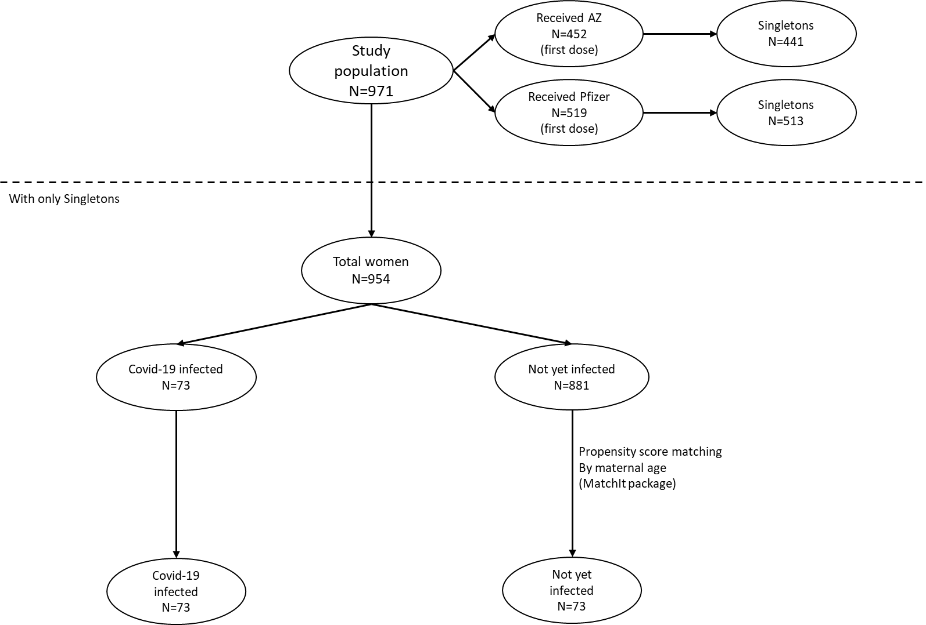

**Statistical analysis**

Data were analyzed using descriptive statistics (mean and standard deviation for normally distributed variables, or median and interquartile range for skewed variables). Differences between groups were analyzed using Fisher’s exact test for categorical variables, Student's t-test for normally distributed continuous variables, and Mann-Whitney test for skewed variables. All analyses were performed using the R statistical packages (R version 3.3.3). Statistical significance was defined as p<0.05.

**Results**

Out of 971 pregnant women, 954 singletons received at least 1 dose of a COVID-19 vaccine before delivery including 441 received the AstraZeneca vaccine and 513 received the Pfizer-BioNTech vaccine. There are 73 women (7.65%) experienced a COVID-19 infection during pregnancy.

**Demographic characteristics**

Demographic characteristics and comorbidities of pregnant women with or without the Covid-19 infection are shown in **table 1**. There was a significant difference in vaccination status between the Covid-19 positive pregnant women (72.6% fully vaccinated; 27.4% only 1 dose) and Covid-19 negative pregnant women (90.4% fully vaccinated; 9.6% only 1 dose), with a p-value of 0.011. There is also a significant difference in the first vaccine type between pregnant women with (32.9% AstraZeneca; 67.1% Pfizer BioNTech) and without (52.1% AstraZeneca; 47.9% Pfizer BioNTech) the Covid-19 infection, with a p-value of 0.03. The second vaccine type, pregnancy type, and gestational age at vaccination were not significantly associated with the Covid-19 infection.

**Table 1. Baseline characteristics of pregnant women with or without the Covid-19 infection**

|  |  |  |  |
| --- | --- | --- | --- |
|  | Not yet infected by Covid-19 | Infected | p value |
|  | N=73 | N=73 |  |
| Maternal age – years | 29.9±4.2 | 29.9±4.2 | 0.95 |
| Previous_pregnancies–n (%) |  |  | 0.95 |
| 0 | 9 (12.3%) | 8 (11.0%) |
| 1 | 29 (39.7%) | 30 (41.1%) |
| 2 | 30 (41.1%) | 30 (41.1%) |
| 3 | 5 (6.8%) | 5 (6.8%) |
| Pregnancy type – n (%) |  |  | 0.95 |
| Assisted | 2 (2.7%) | 3 (4.1%) |
| Natural conceived | 71 (97.3%) | 70 (95.9%) |
| Vaccination status – n (%) |  |  | 0.011 |
| Fully vaccinated | 66 (90.4%) | 53 (72.6%) |
| Only 1 dose | 7 (9.6%) | 20 (27.4%) |
| First vaccine type – n (%) |  |  | 0.03 |
| AstraZeneca | 24 (32.9%) | 38 (52.1%) |
| Pfizer BioNTech | 49 (67.1%) | 35 (47.9%) |
| Second vaccine type – n (%) |  |  | 0.254 |
| AstraZeneca | 22 (33.3%) | 24 (45.3%) |  |
| Pfizer BioNTech | 44 (66.7%) | 29 (54.7%) |  |
| Gestational age at vaccination – weeks | 32.2±4.0 | 31.5±4.1 | 0.242 |
| Gestational HBP – n (%) | 0 (0.0%) | 0 (0.0%) | - |
| Gestational diabetes – n (%) | 10 (13.7%) | 9 (12.3%) | 0.95 |

**Maternal and neonatal outcomes**

The maternal and neonatal outcomes are presented in Table 2. The pregnant women with Covid-19 infection had mean gestational age at birth was higher than in the pregnant women without Covid-19 infection (38.7±1.2 vs 37.9±2.5, p=0.02<0.05). In contrast, the birthweight of pregnant women with the Covid-19 infection was lower than (3372.5±463.5 vs 3196.6±407.6, p=0.016<0.05) and the birthweight percentile was similar (range 75-90, p<0.01).

No maternal or early neonatal death occurred in this cohort study. In addition, rates of gestational hypertension after vaccination, gestational diabetes after vaccination, oligohydramnios, and polyhydramnios did not significantly differ between the groups.

**Table 2. Pregnancy and neonatal outcomes in pregnant women with or without the Covid-19 infection**

|  |  |  |  |  |  |
| --- | --- | --- | --- | --- | --- |
|  | Not yet infected  by Covid-19 | Infected by Covid-19 | RR (95% CI) | Between group difference (95% CI) | p value |
|  | N=73 | N=73 |  |
| Gestational HBP after vaccination – n (%) | 2 (2.7%) | 0 (0.0%) | - | 2.7 [-2.3;7.8] | 0.497 |
| Gestational diabetes after vaccination – n (%) | 0 (0.0%) | 2 (2.7%) | - | 2.7 [-2.3;7.8] | 0.497 |
| Gestational at birth – weeks | 37.9±2.5 | 38.7±1.2 | - | 0.8 [0.11;1.4] | 0.02 |
| Preterm delivery <28 weeks | 1 (1.4%) | 0 (0.0%) | - | 1.4 [-2.6;5.4] | 0.95 |
| Preterm delivery <34 weeks | 4 (5.5%) | 0 (0.0%) | - | 5.5 [-1.1;12.1] | 0.12 |
| Preterm delivery <37 weeks | 10 (13.7%) | 5 (6.8%) | 0.5 [0.2;1.4] | 6.9 [-4.3;18] | 0.276 |
| Gestational oligohydramnios – n (%) | 1 (1.4%) | 6 (8.2%) | 6 [0.7;48.6] | 6.8 [-1.4;15.1] | 0.115 |
| Gestational polyhydramnios – n (%) | 5 (6.8%) | 4 (5.5%) | 0.8 [0.2;2.9] | 1.3 [-7.8;10.5] | 0.95 |
| Maternal ICU events after vaccination – n (%) | 0 (0.0%) | 0 (0.0%) | - | - | - |
| Still birth – n (%) | 0 (0.0%) | 0 (0.0%) | - | - | - |
| Birthweights – grams | 3372.5±463.5 | 3196.6±407.6 | - | 176 [33.1;318.7] | 0.016 |
| Low birthweight – n (%) | 1 (1.4%) | 2 (2.7%) | 2 [0.2;21.6] | 1.3 [-4.5;7.3] | 0.95 |
| Heavy birthweight – n (%) | 3 (4.2%) | 2 (2.7%) | 0.7 [0.1;3.9] | 1.5 [-5.9;8.6] | 0.681 |
| Birthweight percentile – percent | 75.0 [75.0;90.0] | 50.0 [25.0;75.0] | - | - | <0.001 |
| Lower than 10th percentile birthweight – n (%) | 0 (0.0%) | 1 (1.4%) | - | 1.4 [-2.6;5.4] | 0.95 |
| Neonatal ICU events – n (%) | 1 (1.4%) | 4 (5.5%) | 4.0 [0.5;34.9] | 4.1 [-3.1;11.3] | 0.366 |
| Neonatal defects – n (%) | 0 (0.0%) | 1 (1.4%) | - | 1.4 [-2.6;5.4] | 0.95 |

**Discussion**

Many side effects of the Covid-19 vaccine cause concern for pregnant women and obstetricians. However, Covid-19 vaccination in pregnant women decreased the rates of covid-19 infection during pregnancy and did not result in increasing the adverse outcomes for maternal and neonatal.

During the Covid-19 pandemic in Vietnam, from August 2021 to December 2021, My Duc Hospital and My Duc Phu Nhuan Hospital received 954 singletons, including 73 Covid-19 positive pregnant women. In this prospective cohort study, we compared this group of women with and without Covid-19 infection. The mother's ages and the number of their previous pregnancies were matched into two groups. Baseline characteristics factors associated with Covid-19 infection included vaccination status and first vaccine type.

In this study, we found that the birthweight of vaccinated pregnant women with Covid-19 infection was significantly lower but it has no pathological significance and does not cause adverse neonatal outcomes. Covid-19 infection was reported to have as much as 50 post-viral infection long-term effects, mostly on the body’s physical and mental health (<https://www.nature.com/articles/s41598-021-95565-8>). Studies on neonatal outcomes such as preterm birth, neonates diseases, the intensive care admission rate, etc. (<https://academic.oup.com/tropej/article/67/5/fmab094/6423225>; <https://pubmed.ncbi.nlm.nih.gov/34620797/>; <https://www.nature.com/articles/s41390-021-01875-y#Sec12>).

**Conclusion**

Although Covid-19 infection during pregnancy is increased significantly adverse maternal and neonatal outcomes in multiple studies, the current findings should give clinicians assurance that Covid-19 vaccination during pregnancy is protective against maternal SARS-CoV-2 infection and no evidence of adverse maternal or neonatal outcomes.

**Acknowledgment**

**References**

1. Diễn biến dịch COVID-19 mới nhất. https://covid19.gov.vn/big-story/cap-nhat-dien-bien-dich-covid-19-moi-nhat-hom-nay-171210901111435028.htm.

2. Lokken, E. M. *et al.* Higher severe acute respiratory syndrome coronavirus 2 infection rate in pregnant patients. *American Journal of Obstetrics and Gynecology* **225**, 75.e1-75.e16 (2021).

3. Dooling, K. *et al.* The Advisory Committee on Immunization Practices’ Updated Interim Recommendation for Allocation of COVID-19 Vaccine — United States, December 2020. *MMWR. Morbidity and Mortality Weekly Report* **69**, 1657–1660 (2020).

4. Zambrano, L. D. *et al.* Update: Characteristics of Symptomatic Women of Reproductive Age with Laboratory-Confirmed SARS-CoV-2 Infection by Pregnancy Status - United States, January 22-October 3, 2020. *MMWR Morb Mortal Wkly Rep* **69**, 1641–1647 (2020).

5. Villar, J. *et al.* Maternal and Neonatal Morbidity and Mortality Among Pregnant Women With and Without COVID-19 Infection: The INTERCOVID Multinational Cohort Study. *JAMA Pediatrics* **175**, 817–826 (2021).

6. JCVI issues new advice on COVID-19 vaccination for pregnant women - GOV.UK. https://www.gov.uk/government/news/jcvi-issues-new-advice-on-covid-19-vaccination-for-pregnant-women.

7. Shimabukuro, T. T. *et al.* Preliminary Findings of mRNA Covid-19 Vaccine Safety in Pregnant Persons. *New England Journal of Medicine* **384**, 2273–2282 (2021).

8. Kachikis, A. *et al.* Short-term Reactions Among Pregnant and Lactating Individuals in the First Wave of the COVID-19 Vaccine Rollout. *JAMA Network Open* **4**, e2121310–e2121310 (2021).